|  |  |  |
| --- | --- | --- |
|  |  |  |
|  |  |  |
|  |  |  |
|  |
|  |
| **Testing, Feedback Analysis, and Evaluation the Software Solution**  **Moayad Hamdan** |
|  | **To: Dern-Support** |  |
|  |  |  |
|  |  |  |

Contents

1. Testing the Software Solution 3

1.1 Test Plans 3

1.2 Live Test Cases and Results 3

Test Case 1: Support Request Submission 3

Test Case 2: Account Creation and Login 5

Test Case 3: Inventory Management 9

Test Case 4: Scheduling Repairs 12

Test Case 5: User Page View Knowledge Base 14

Test Case 6: Admin Page - Manage Requests and Jobs 15

1.3 Documenting Problems and Errors 19

Error 1: Slow Response Time 19

Error 2: Inventory Sync Issue 19

Error 3: Registration with Existing Username 20

Error 4: Registration with Invalid Password 21

Error 5: Invalid Login Attempt 22

Error 6: Submitting a Request Without Required Fields 24

Error 7: Scheduling a Repair with an Old Date 25

Feedback Analysis and Refinement 27

2.1 Gathering Feedback 27

2.2 Refining the Solution 27

3. Evaluation of the Solution 29

3.1 Efficiency 29

3.2 Effectiveness 37

3.3 Requirement Fulfillment 37

3.4 Future Development Suggestions 38

# 1. Testing the Software Solution

## 1.1 Test Plans

**Test Plan Overview:** This document outlines the strategy for live testing the Dern-Support full-stack solution. Live tests involve manually interacting with the web application to verify that it performs as expected.

**Testing Objectives:**

* Verify functionality of key features through direct interaction.
* Ensure performance meets requirements under real-world conditions.
* Validate usability from an end-user perspective.

## 1.2 Live Test Cases and Results

### Test Case 1: Support Request Submission

* **Objective:** Verify that users can submit support requests.
* **Test Steps:**
  1. Navigate to the support request submission page.
  2. Enter a title and description for a new support request.
  3. Click "Submit" and observe the outcome.
* **Expected Result:** The request should be successfully submitted and visible in the user’s support request history.
* **Actual Result:**

User Page Requests SUBMIT A REQUEST:  
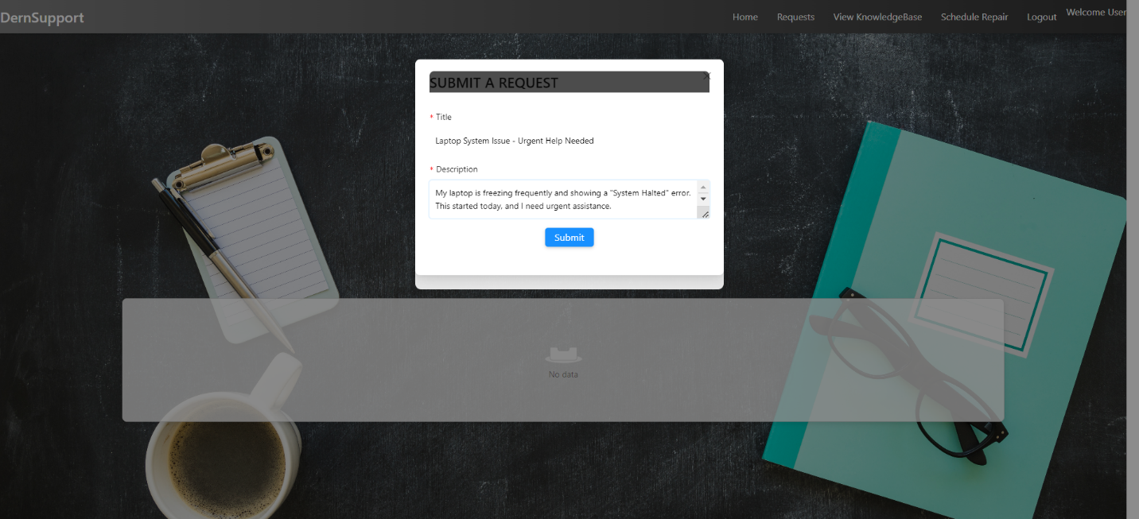

User Page Requests SUBMIT A REQUEST 1

User Page Requests SUBMIT A REQUEST Successful And return it:  
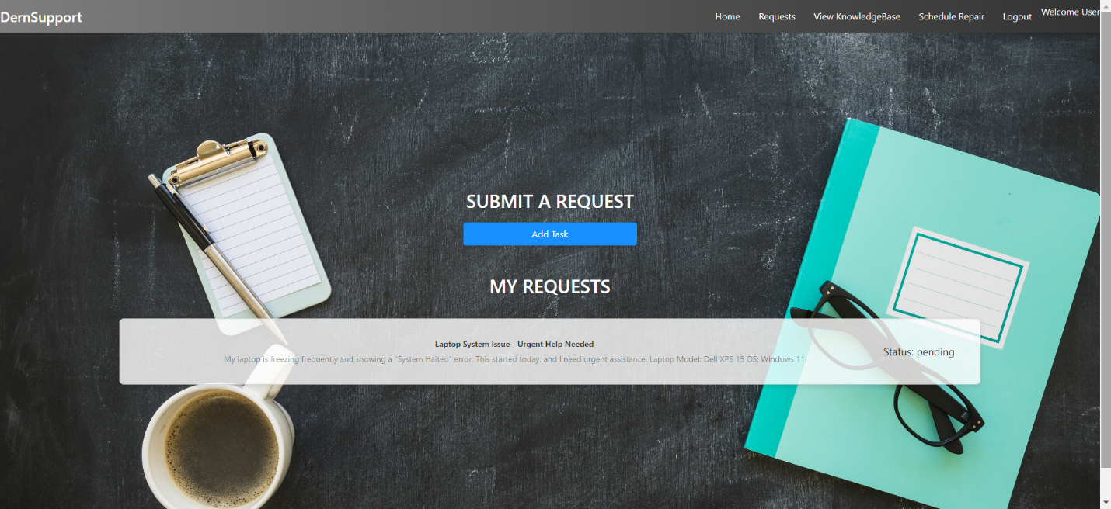

User Page Requests SUBMIT A REQUEST Succ 1

**Observations:** The support request was successfully submitted, and the confirmation message was displayed. The request also appeared in the user's support request history as expected.

### Test Case 2: Account Creation and Login

* **Objective:** Ensure that both individual and business accounts can be created and logged in.
* **Test Steps:**
  1. Navigate to the account creation page.
  2. Create a new account with valid details.
  3. Log in using the newly created account.
* **Expected Result:** The account should be created successfully, and the user should be able to log in and view their profile.
* **Actual Result:**

Home Page:  
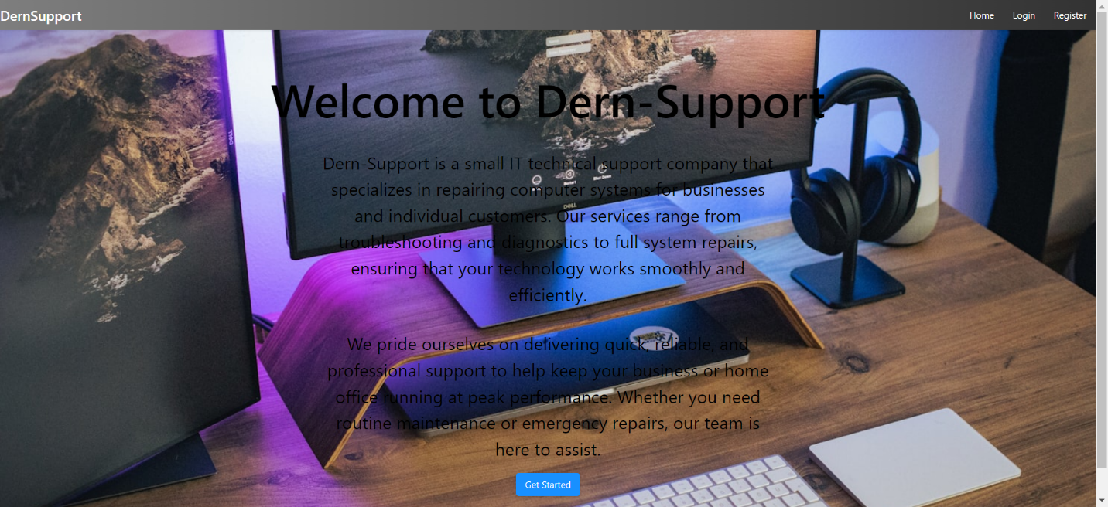

Home Page 1

Register Page:  
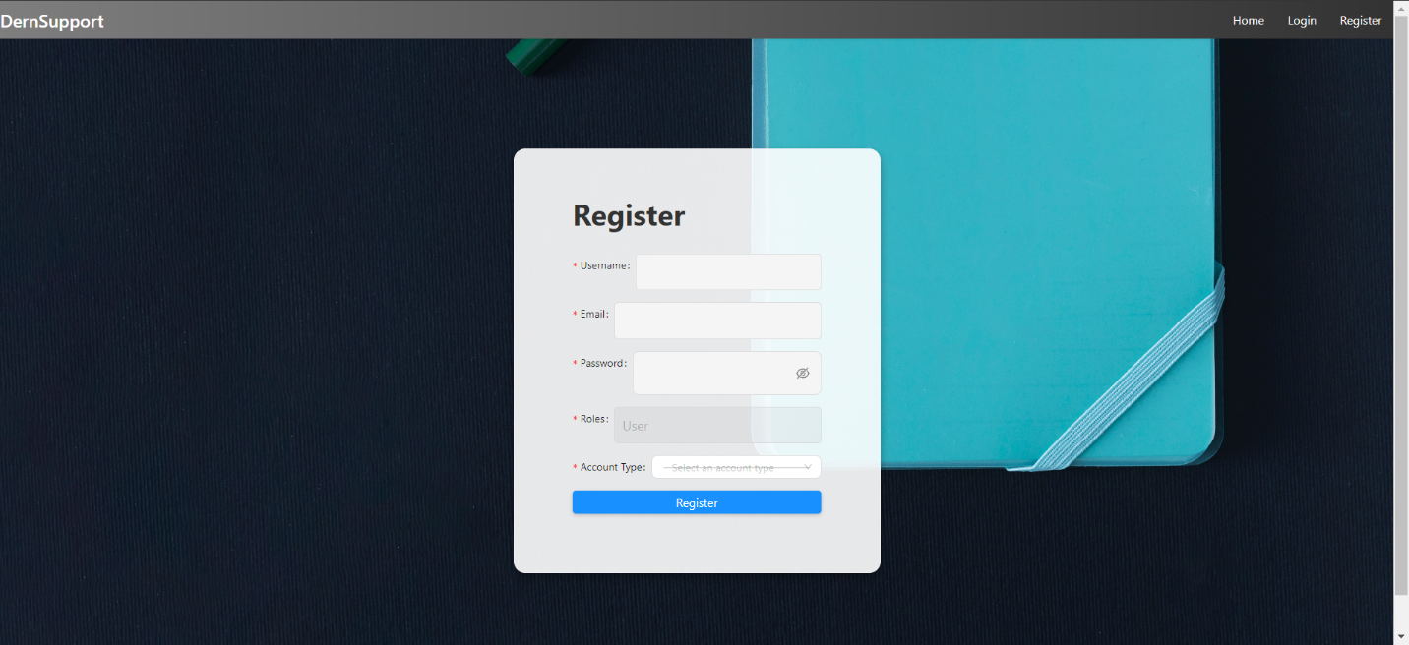

Register Page 1

Register Page Select Account Type:  
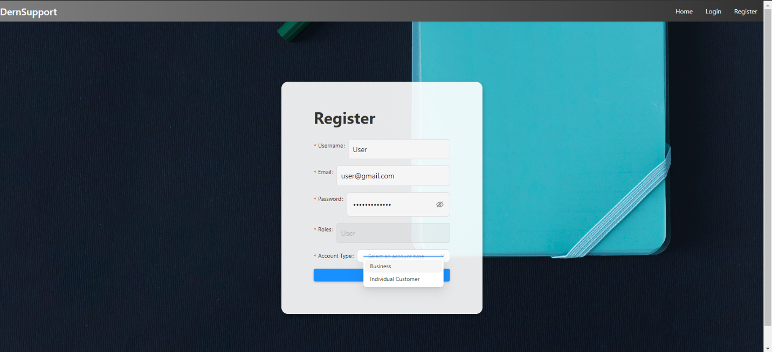

Register Page Select Account Type 1

Register Page Business Account:  
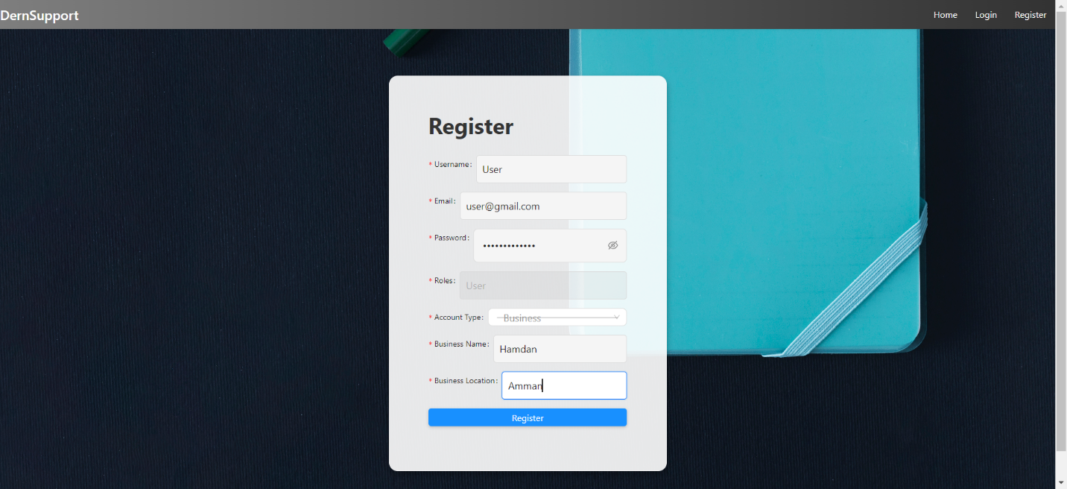

Register Page Business Account 1

Register Page Individual Customer Account:  
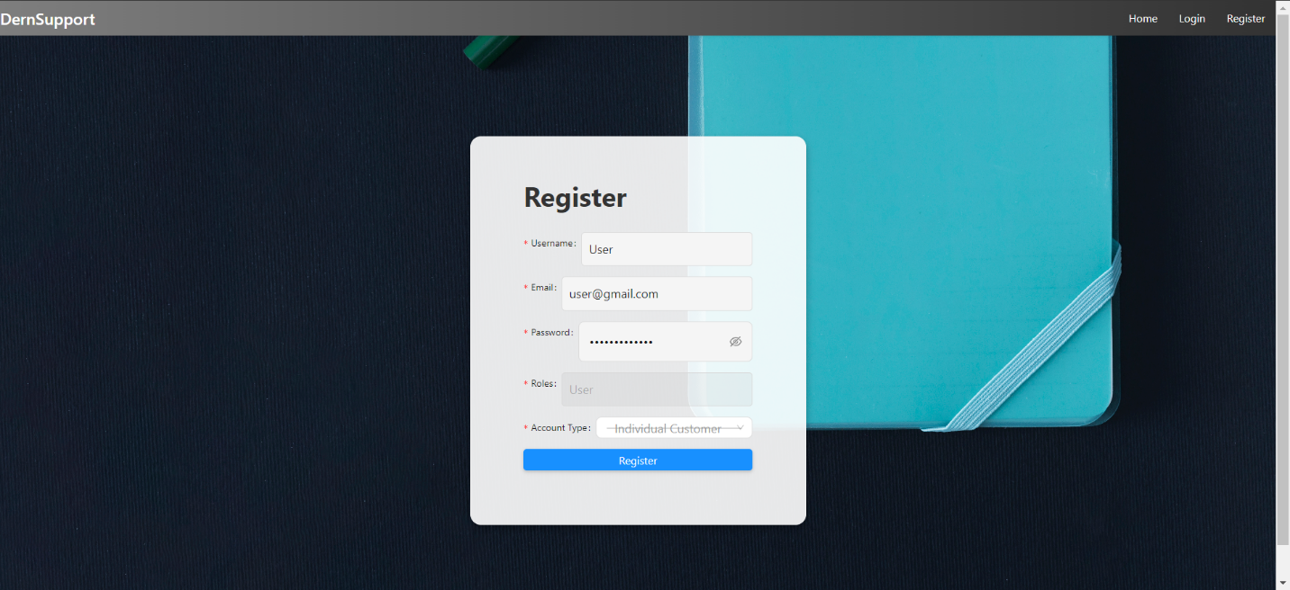

Register Page Individual Customer Accoun 1

Register Page Registration Successful:  
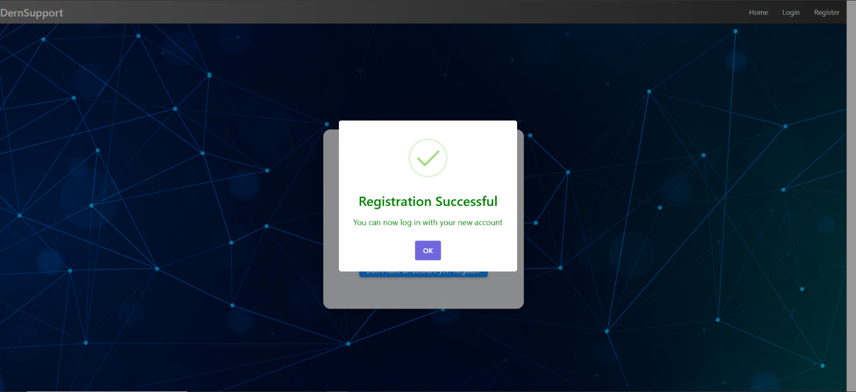

Register Page Registration Successful 1

Login Page:  
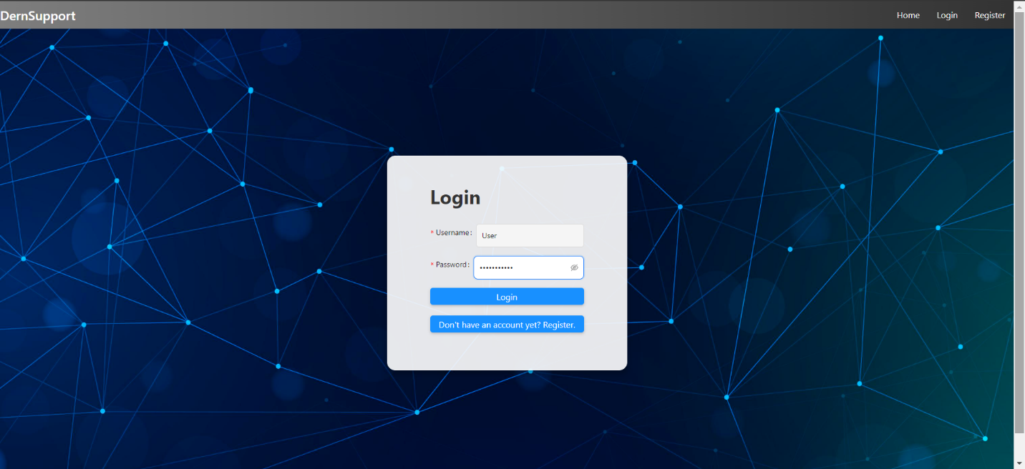

Login Page 1

User Page:  
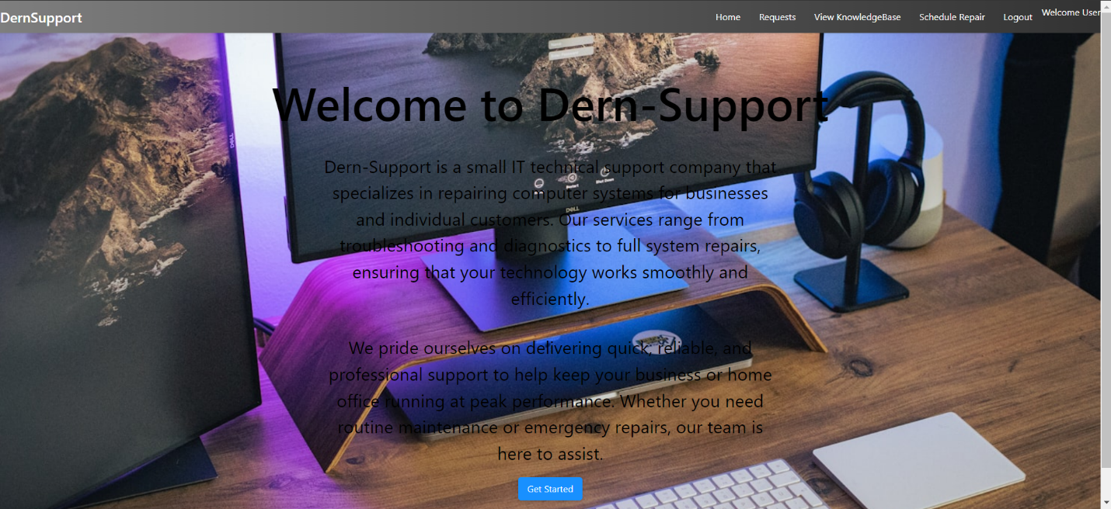

User Page 1

**Observations:** Account creation and login were successful. The user was able to access their profile and view their support requests.

### Test Case 3: Inventory Management

* **Objective:** Ensure real-time updates in inventory management.
* **Test Steps:**
  1. Navigate to the inventory management page.
  2. Update the inventory for a spare part.
  3. Check if the updated information is reflected immediately.
* **Expected Result:** Inventory updates should be visible in real-time.
* **Actual Result:**

Admin Page IT Stocks:  
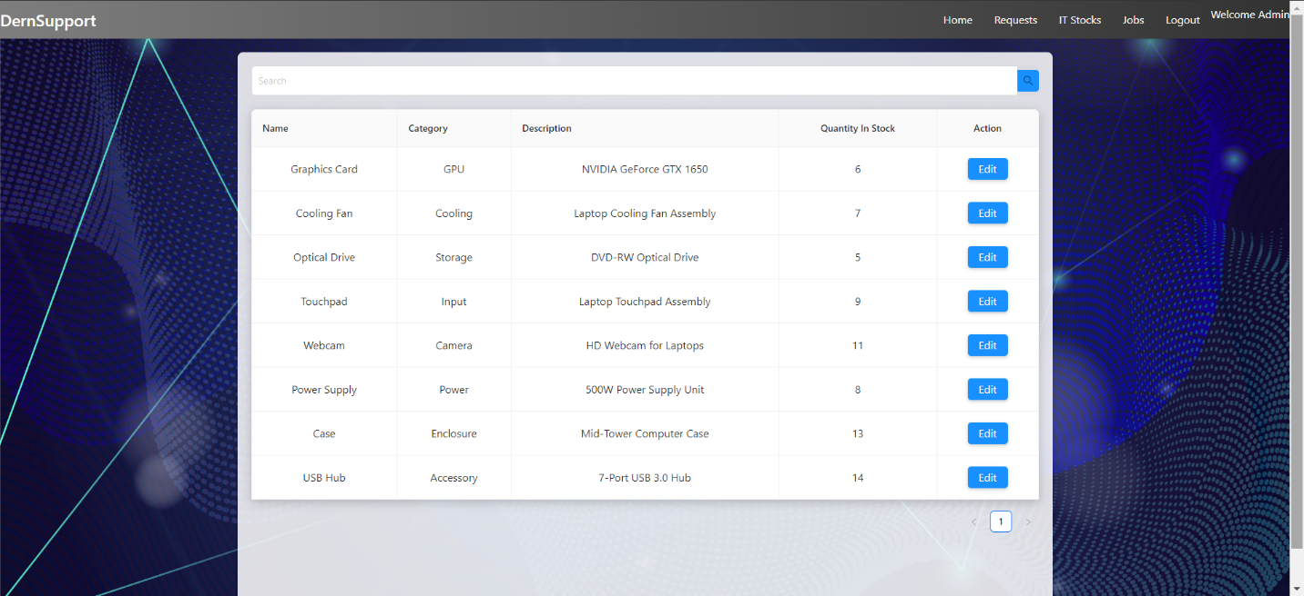

Admin Page IT Stocks 1

Admin Page IT Stocks Search:  
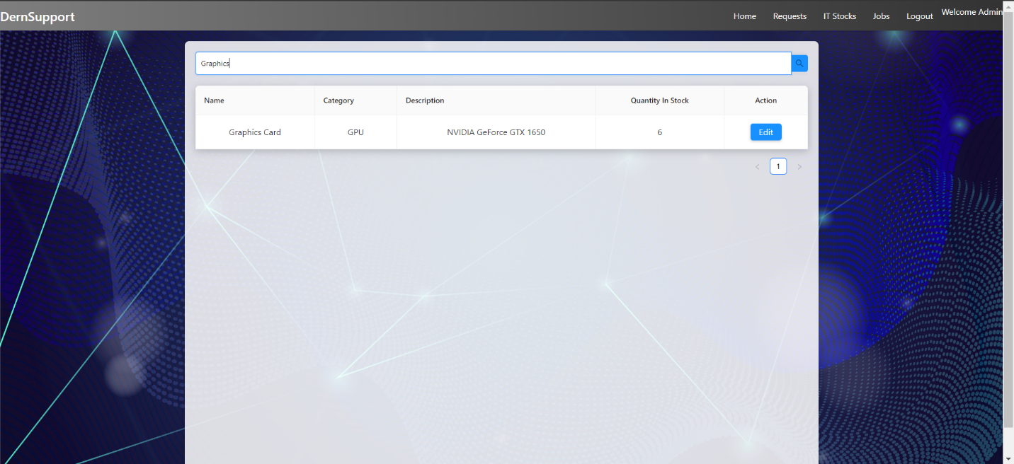

Admin Page IT Stocks Search 1

Admin Page IT Stocks Edit Stock:  
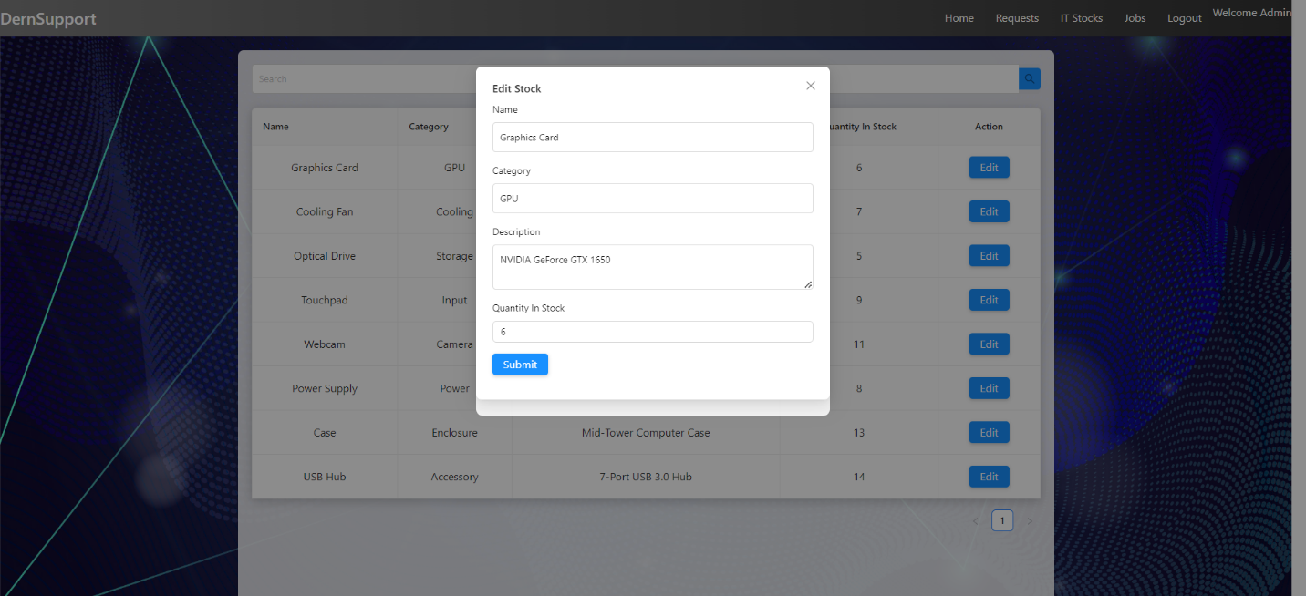

Admin Page IT Stocks Edit Stock 1

Admin Page IT Stocks Edited Stock Successful:  
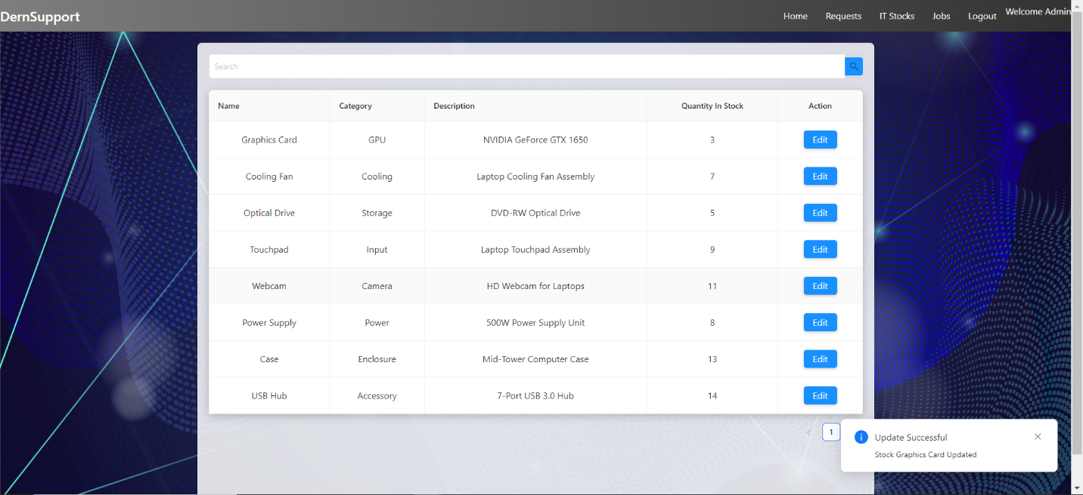

Admin Page IT Stocks Edited Stock Succes 1

**Observations:** The inventory update was reflected in real-time, with updated details visible immediately after the change.

### Test Case 4: Scheduling Repairs

* **Objective:** Verify that users can schedule repair appointments.
* **Test Steps:**
  1. Navigate to the repair scheduling page.
  2. Choose a service, view available dates, and schedule an appointment.
* **Expected Result:** The repair appointment should be scheduled successfully, and the user should receive a confirmation.
* **Actual Result:**

User Page Schedule Repair:  
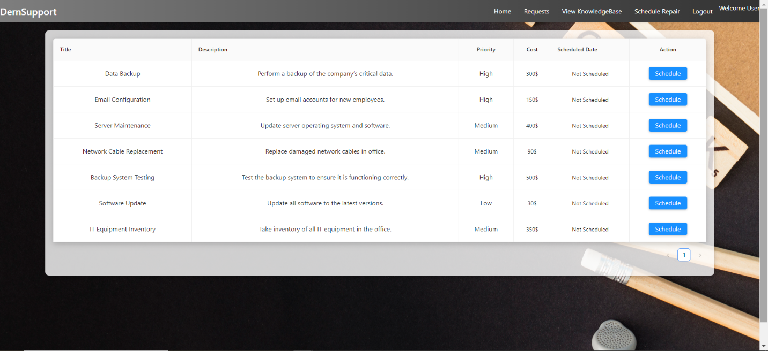

User Page Schedule Repair 1

User Page Schedule Repair Scheduled Date:  
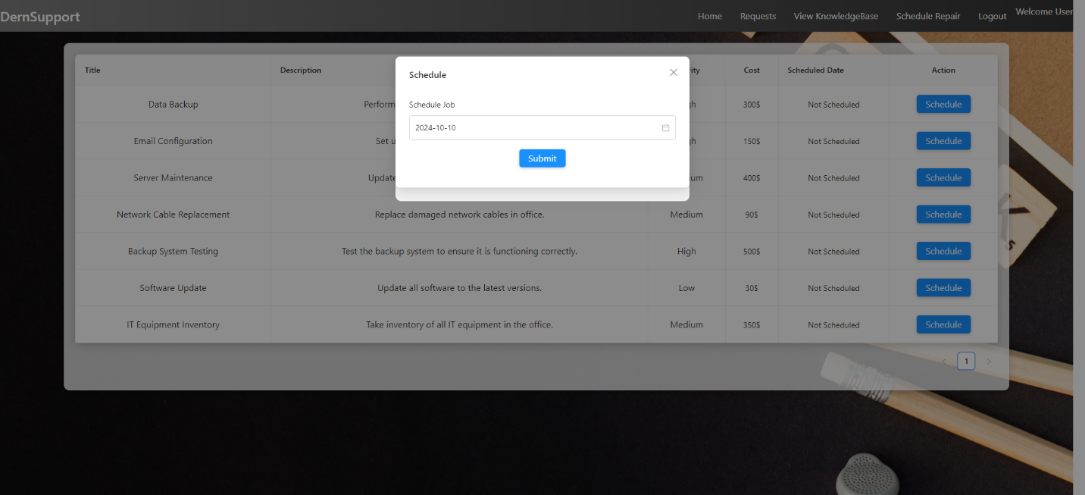

User Page Schedule Repair Scheduled Date 1

User Page Schedule Repair Scheduled Date Schedul Successful:  
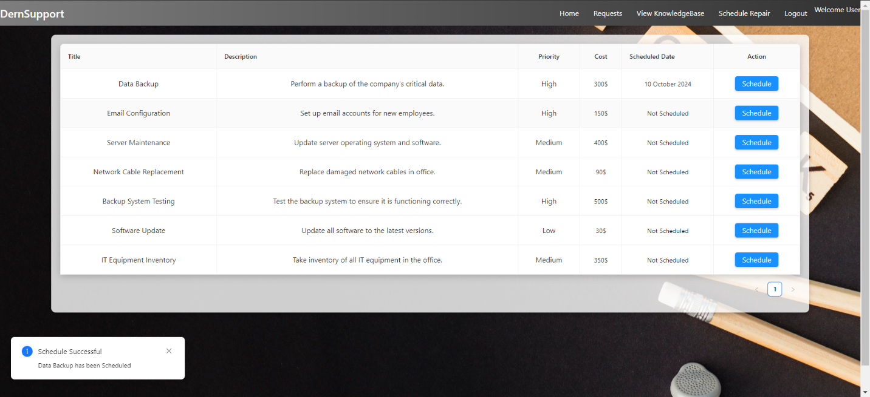

User Page Schedule Repair Scheduled Date 2

**Observations:** Repair scheduling was successful, and a confirmation message was displayed.

### Test Case 5: User Page View Knowledge Base

* **Objective:** Verify that users can view and access the knowledge base on their profile page.
* **Test Steps:**
  1. **Navigate to the User Profile Page:** Log in to the application and go to the user profile page.
  2. **Access the Knowledge Base:** Locate and click on the "Knowledge Base" section or link on the user profile page.
  3. **View Knowledge Base Content:** Browse through the available diagnostic tools and instructional guides. Click on specific items to view detailed information.
* **Expected Result:**
* The user should be able to access the knowledge base from their profile page.
* Users should be able to view and navigate through the diagnostic tools and instructional guides.
* Clicking on individual items should display detailed content correctly.
* **Actual Result:**

User Page View KnowledgeBase:  
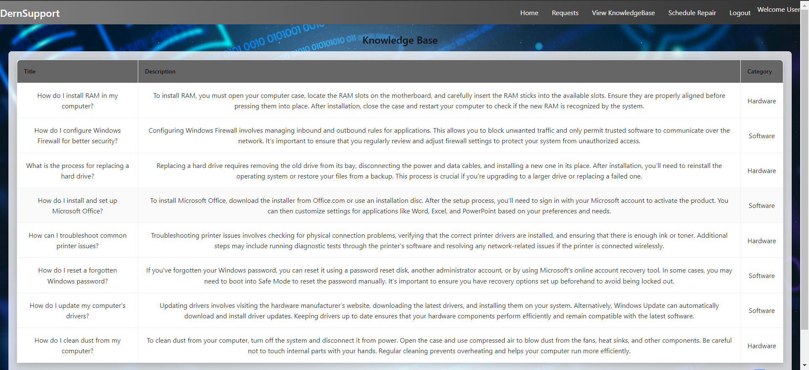

User Page View KnowledgeBase 1

* **Observations:**
  + The knowledge base section was successfully accessible from the user profile page.
  + Users could browse and view diagnostic tools and instructional guides without issues.
  + All content displayed correctly, and navigation was smooth.

### Test Case 6: Admin Page - Manage Requests and Jobs

* **Objective:** Verify that admins can view and manage declined and approved support requests, as well as view job details on the admin page.
* **Test Steps:**
  1. **Navigate to the Admin Dashboard:** Log in to the application as an admin and access the admin dashboard.
  2. **View Declined Requests:**

Locate and click on the "Declined Requests" section or link.

Browse through the list of declined requests to verify that all requests are visible with correct details.

* 1. **View Approved Requests:**

Locate and click on the "Approved Requests" section or link.

Browse through the list of approved requests to verify that all requests are visible with correct details.

* 1. **View Jobs:**

Locate and click on the "Jobs" section or link.

Browse through the list of jobs to ensure all job details, including status and assigned technicians, are visible.

* 1. **Expected Result:**
* Admins should be able to access and view the declined requests section with all declined requests and details.
* Admins should be able to access and view the approved requests section with all approved requests and details.
* Admins should be able to access and view the jobs page with all job details, including status and assigned technicians.
* **Actual Result:**

Admin Page:  
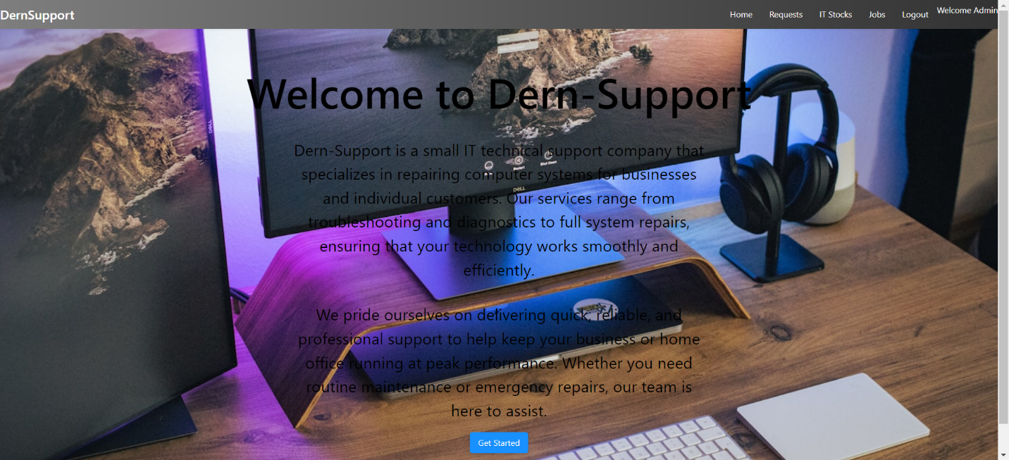

Admin Page 1

Admin Page Requests:  
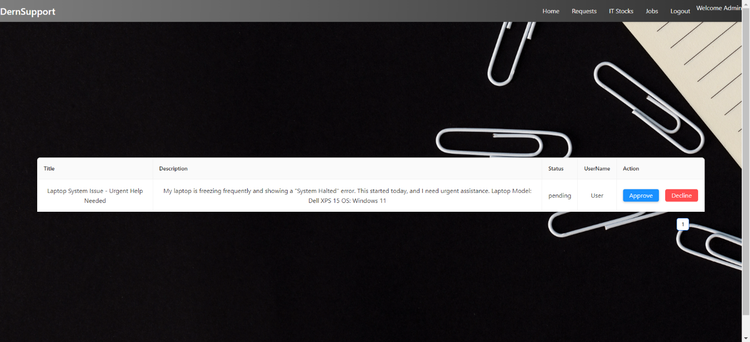

Admin Page Requests 1

Admin Page Requests Approved Request:

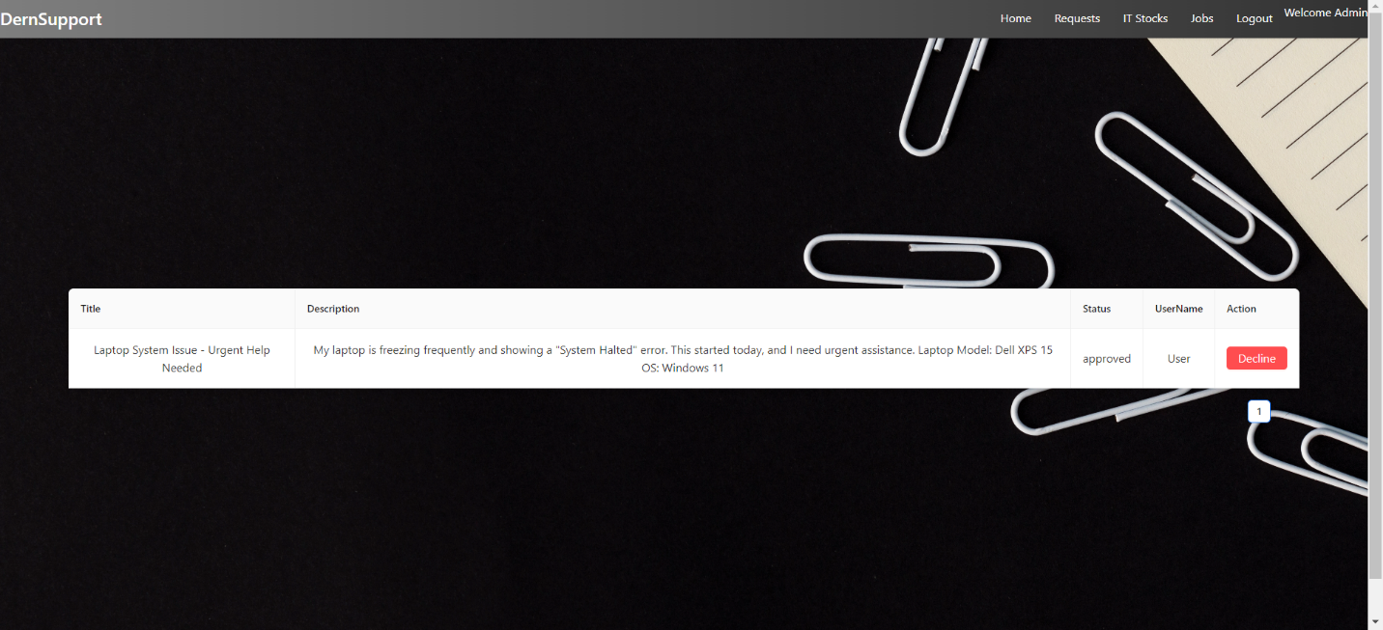

Admin Page Requests Approved Request 1

Admin Page Requests Declined Request:  
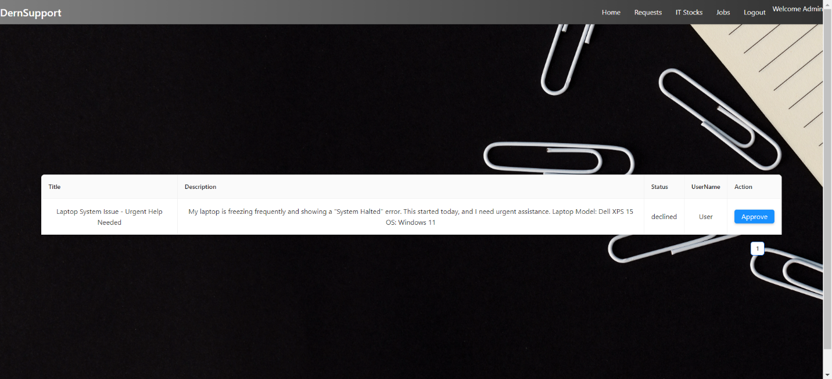

Admin Page Requests Declined Request 1

Admin Page Jobs:  
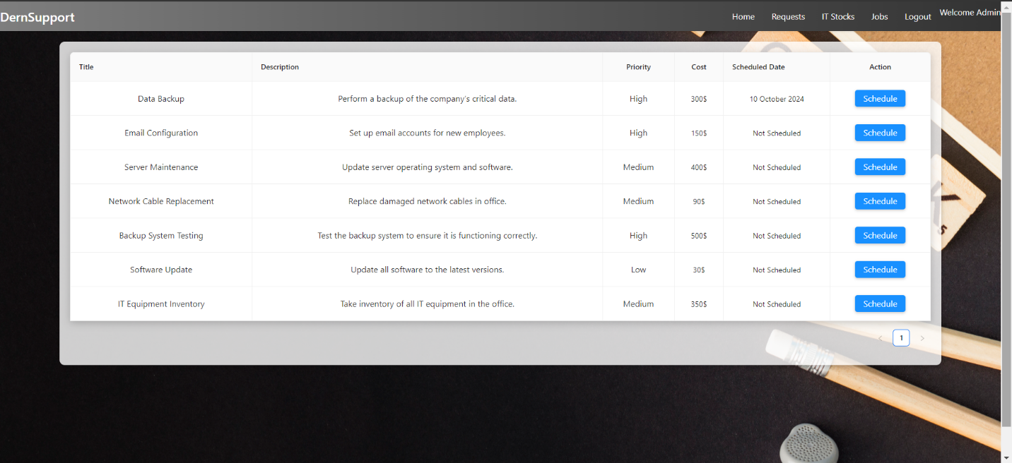

Admin Page Jobs 1

* **Observations:**
  + The "Declined Requests" section was accessible and displayed all declined requests with accurate details.
  + The "Approved Requests" section was accessible and displayed all approved requests with accurate details.
  + The "Jobs" page was accessible and displayed all job details correctly, including status and assigned technicians.

.

## 1.3 Documenting Problems and Errors

### Error 1: Slow Response Time

* **Issue:** Observed slow response time when submitting support requests during peak hours.
* **Resolution:** Performance optimization was carried out, including query optimization and load balancing.

### Error 2: Inventory Sync Issue

* **Issue:** Initial delay in reflecting inventory updates in real-time.
* **Resolution:** Implemented real-time notifications for inventory changes to ensure immediate updates.

Admin Page IT Stocks Edited Stock Successful:



Admin Page IT Stocks Edited Stock Succes 2

### Error 3: Registration with Existing Username

* **Issue:** Tried to register with an existing username and received a "Registration Failed" error.
* **Resolution:** Implemented a validation check to prevent users from registering with an already existing username. Now the system provides a clear error message indicating that the username is taken and prompts the user to choose a different one.

Try To Register With Username Exist:  
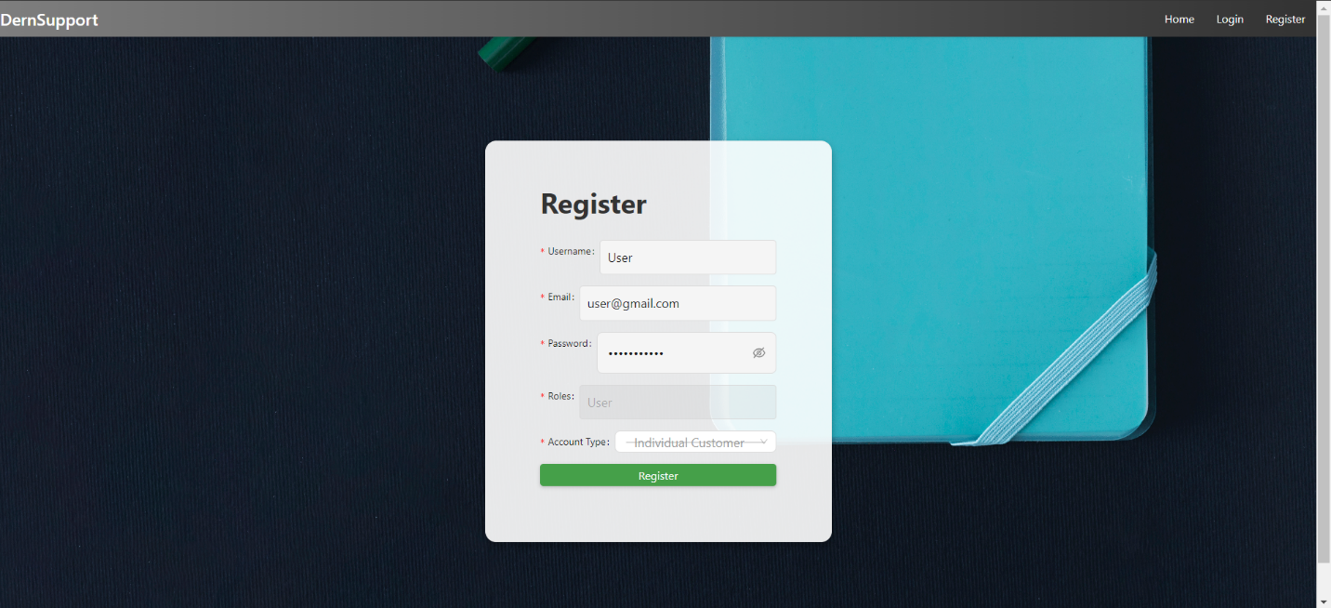

Try To Register With UserName Exist 1

Return Registration Failed:  
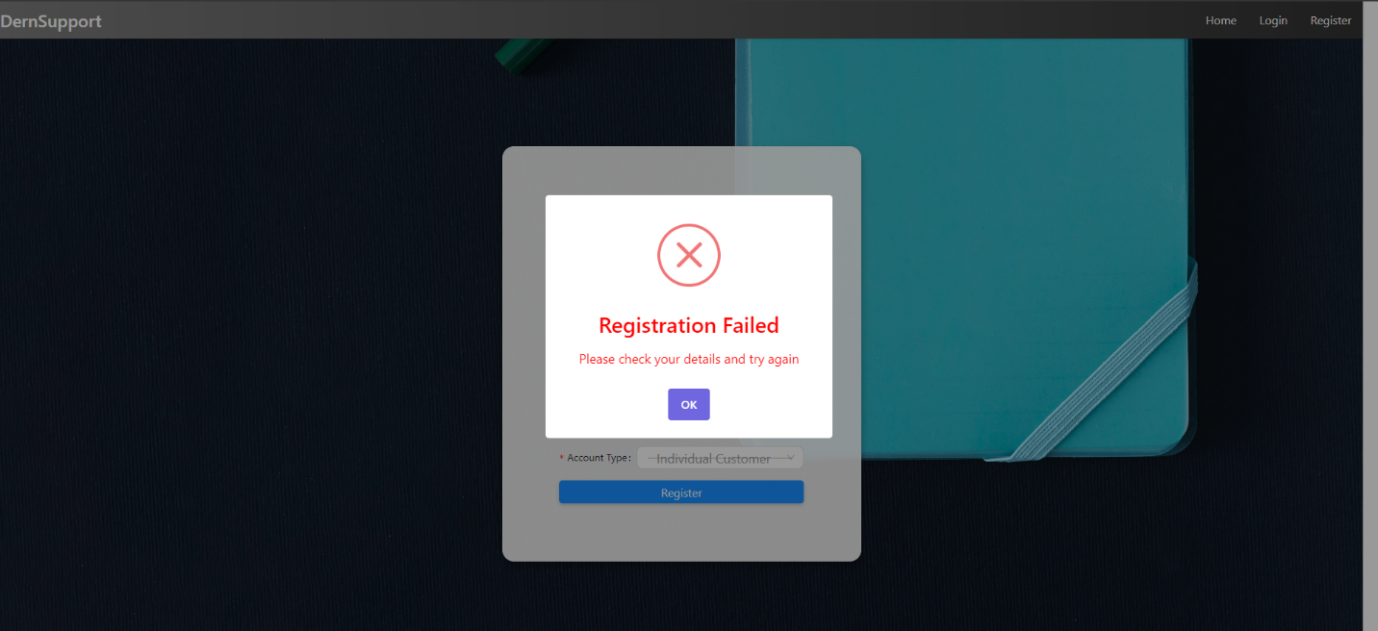

Return Registration Failed 1

### Error 4: Registration with Invalid Password

* **Issue:** Tried to register with an invalid password (e.g., too short or missing special characters) and received a "Registration Failed" error.
* **Resolution:** Added password validation rules to ensure that passwords meet the security requirements (minimum length, special characters, etc.). The system now displays an appropriate error message guiding users to create a valid password.

Try To Register With Invalid Password:  
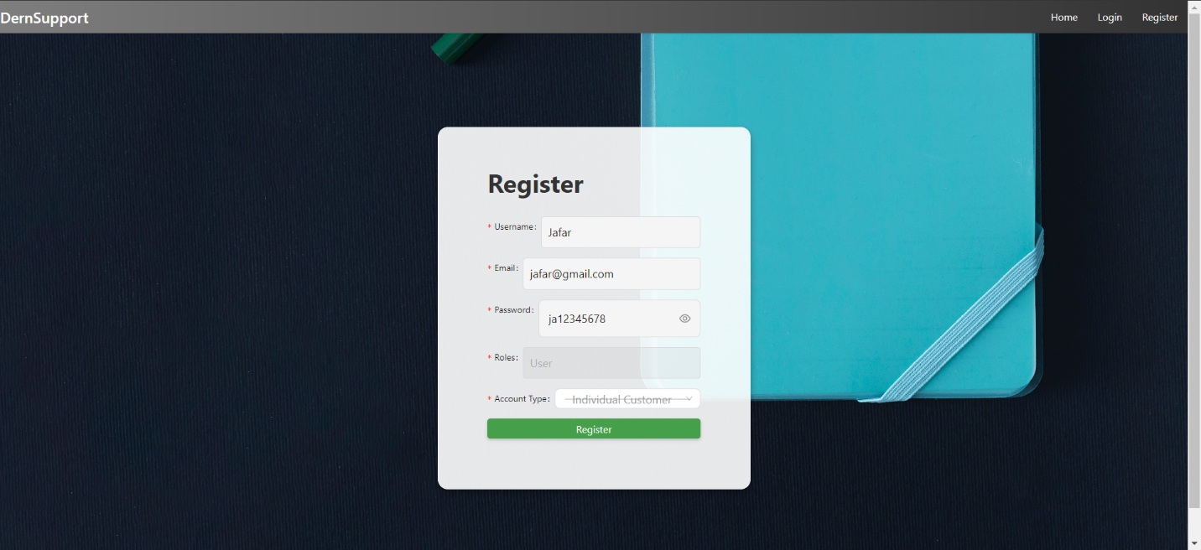

Try To Register With Invalid Password 1

Return Registration Failed:  


Return Registration Failed 2

### Error 5: Invalid Login Attempt

* **Issue:** Tried to log in with an incorrect username or password, resulting in "Invalid Credentials."
* **Resolution:** Enhanced the login process to provide a clearer error message. Now, when invalid credentials are entered, the system immediately returns an "Invalid Credentials" error, prompting the user to try again or reset the password.

Try To Login With Invalid Username or Password:  
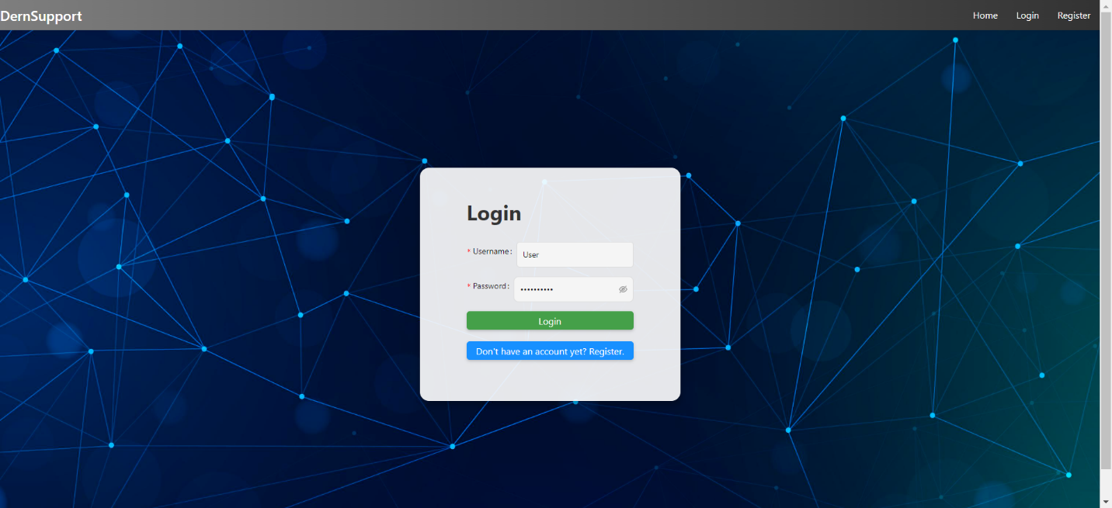

Try To Login With Invalid Username or Pa 1

Return Invalid Credentials:  
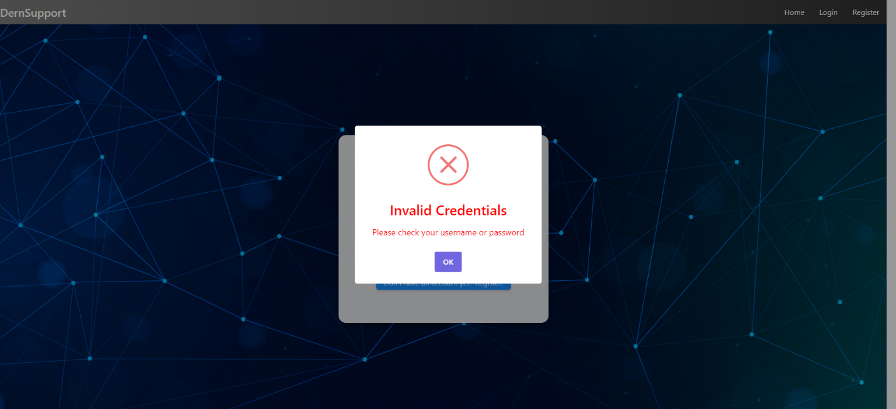

Return Invalid Credentials 1

### Error 6: Submitting a Request Without Required Fields

* **Issue:** Tried to submit a support request without filling in all the required fields, resulting in "Submission Failed."
* **Resolution:** Added mandatory field validation. The system now prevents request submission until all required fields (title, description) are filled and highlights missing fields with error messages.

Try to SUBMIT A REQUEST Without Fill:  
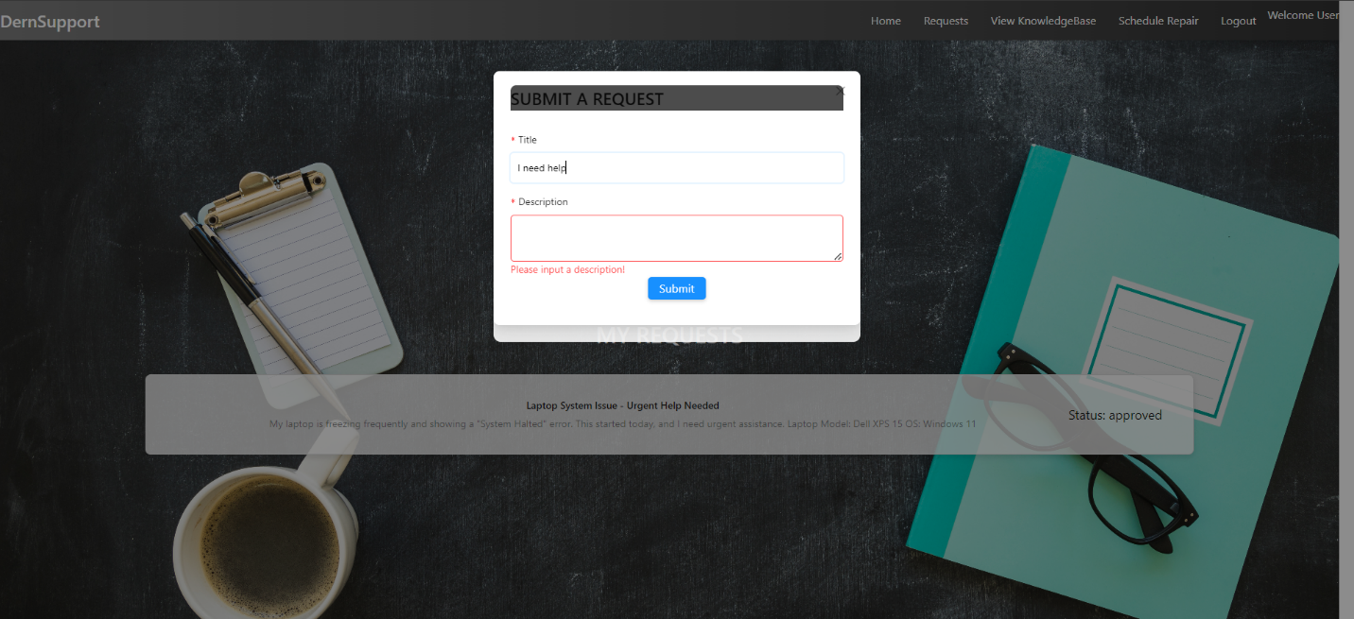

Try to SUBMIT A REQUEST Without Fill 1

Return Submission Failed:  
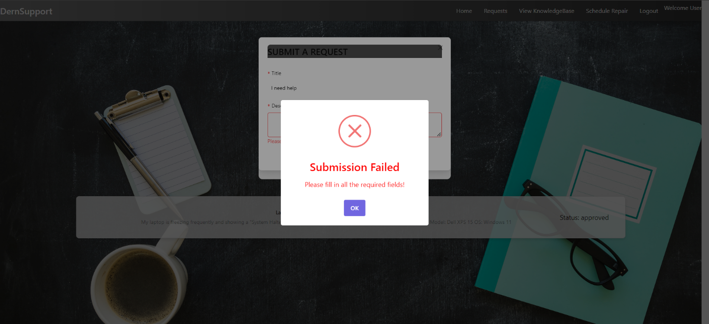

Return Submission Failed 1

### Error 7: Scheduling a Repair with an Old Date

* **Issue:** The system allowed users to schedule repairs with dates in the past, resulting in scheduling conflicts.
* **Resolution:** Added a date validation check. Users can no longer schedule repairs for past dates, and an error message is shown when attempting to do so. The system now only allows future dates to be selected.

User Can Schedule Repair With Old Date:  
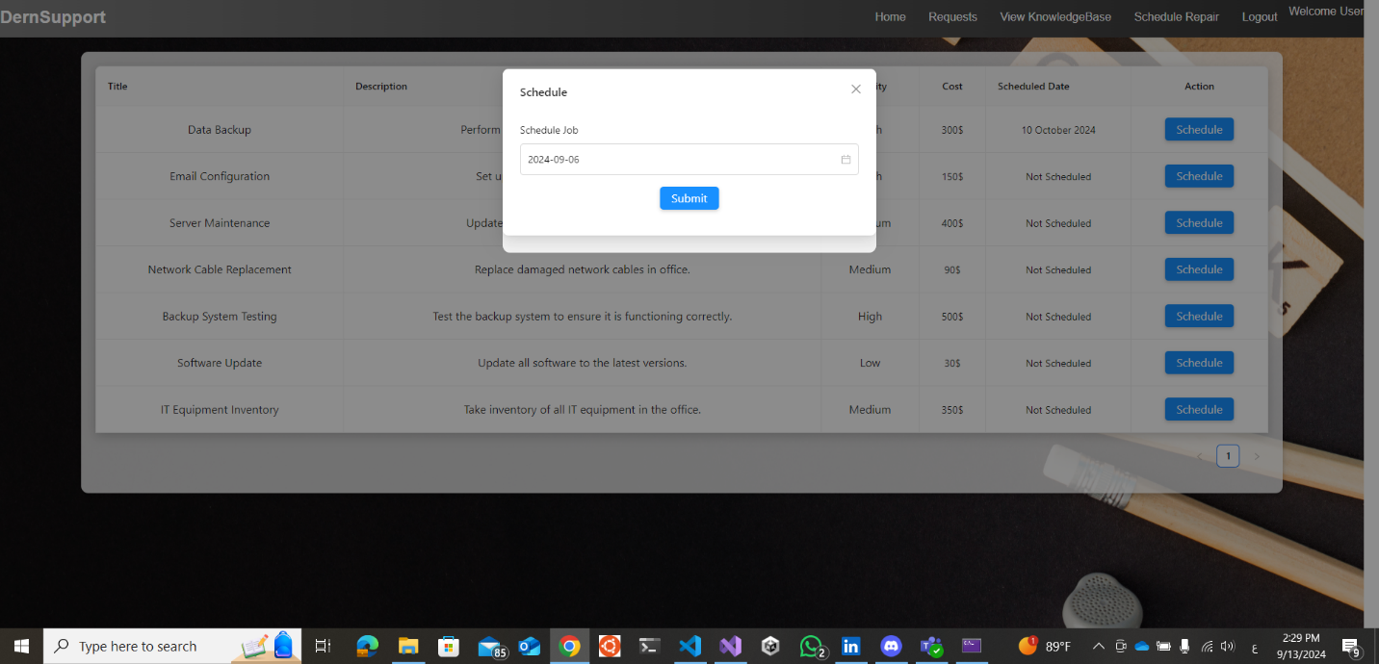

User Can Schedule Repair With Old Date 1

User Can't Schedule Repair With Old Date:  
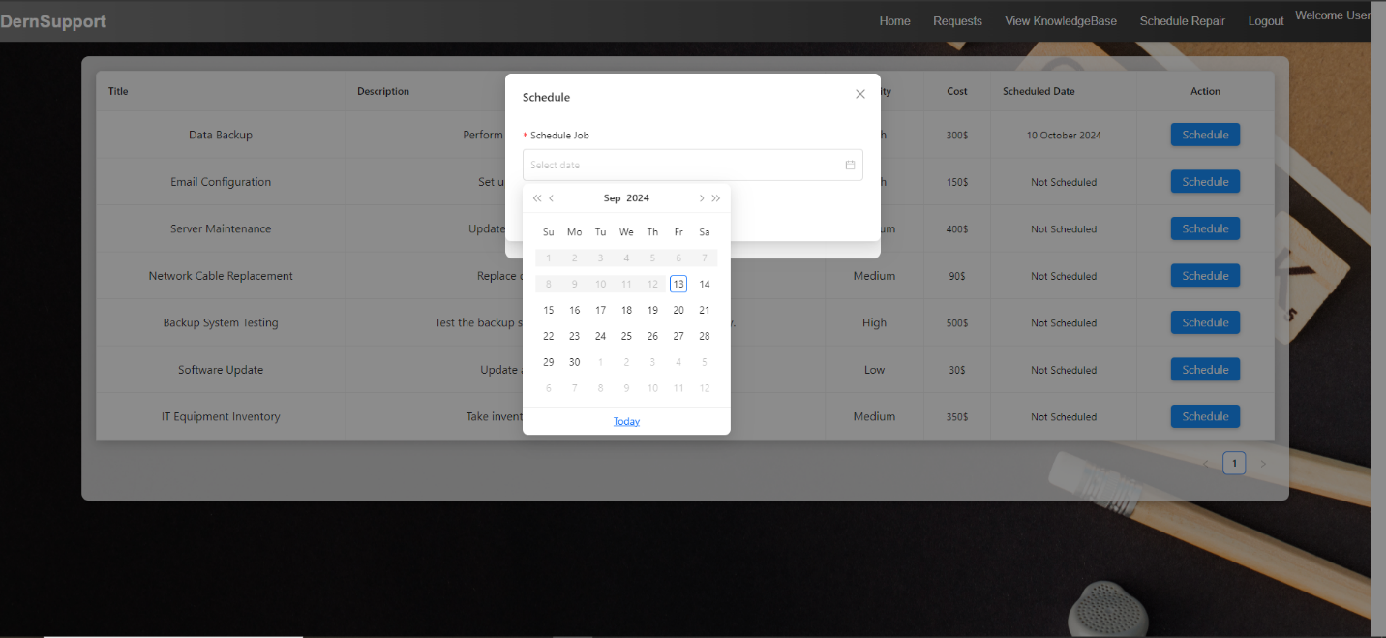

User Can't Schedule Repair With Old Date 1

# Feedback Analysis and Refinement

## 2.1 Gathering Feedback

**Feedback Methods:**

* **User Testing Sessions:** Engaged users to interact with the system and provide feedback on its design and functionality.
* **Surveys:** Distributed post-testing surveys to gather opinions on usability, functionality, and design elements.

**Key Feedback Points:**

* **Usability:** Users appreciated the intuitive design but suggested additional search filters for inventory and a footer for easier navigation and access to important links.
* **Performance:** Some users experienced delays under heavy load.
* **Design:** Users recommended that the footer should include quick links to privacy policies, terms of service, contact information, and social media handles.
* **Features:** There was a request for a mobile-friendly design.

## 2.2 Refining the Solution

**Refinement Actions:**

* **Enhanced Navigation:** Added additional filters for inventory searches based on user feedback to improve search functionality.
* **Footer Implementation:** A footer was designed and added to the website, incorporating:
  + Quick links to important sections like privacy policies, terms of service, and FAQs.
  + Contact information for easier communication.
  + Social media links for broader engagement and accessibility.
* **Performance Improvements:** Optimized system performance to handle higher loads effectively.
* **Mobile Compatibility:** Initiated development of a mobile-friendly interface to meet user requests.

Page IT Stocks Search:  


Page IT Stocks Search 1

Footer:  
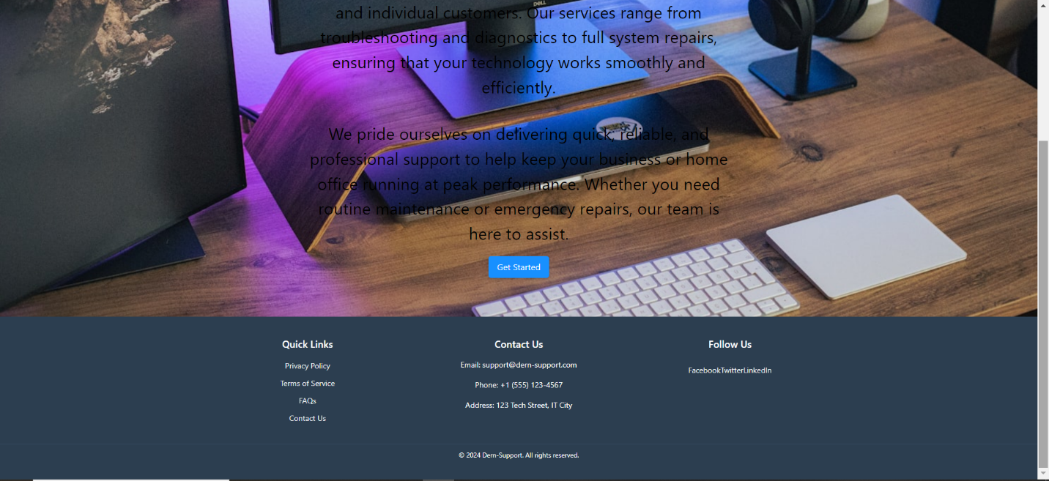

Footer 1

# 3. Evaluation of the Solution

## 3.1 Efficiency

* **Performance:** Achieved response times under the required 2 seconds for most operations.
* **Resource Utilization:** Efficient database usage with optimized queries and real-time updates.

DernSupportDB:  
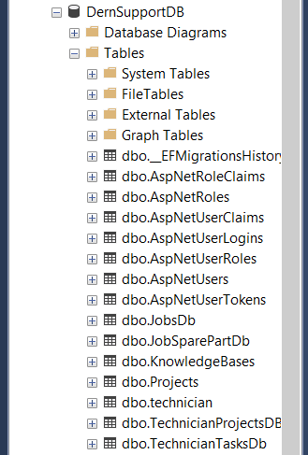

DernSupportDB 1

AspNetUsers Table:  
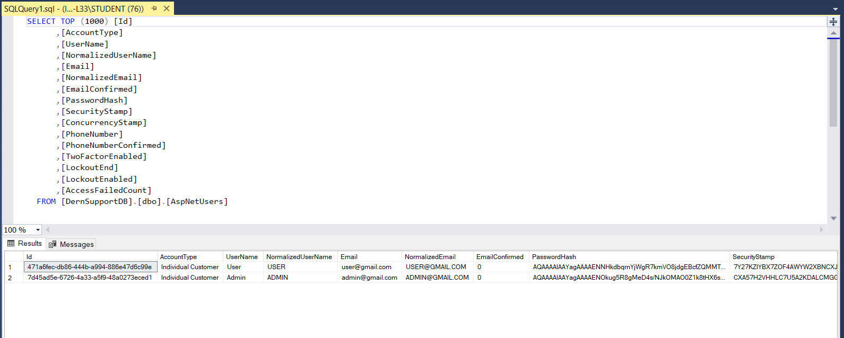

AspNetUsers Table 1

AspNetRoles Table:  
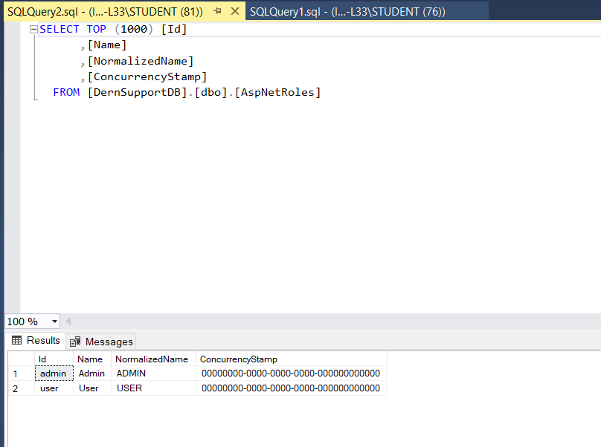

AspNetRoles Table 1

JobsDb Table:  
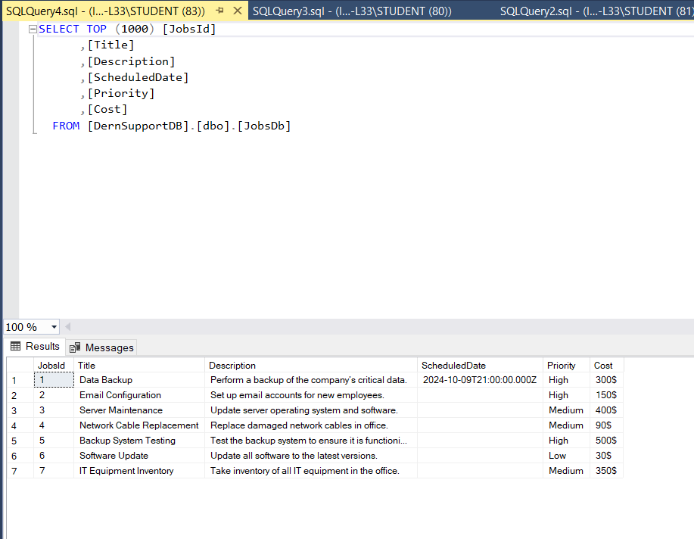

JobsDb Table 1

JobSparePartDb Table:  
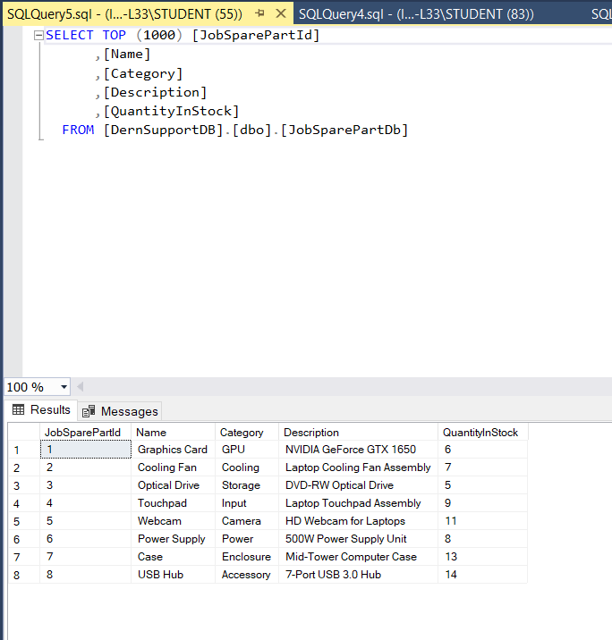

JobSparePartDb Table 1

KnowledgeBases Table:  
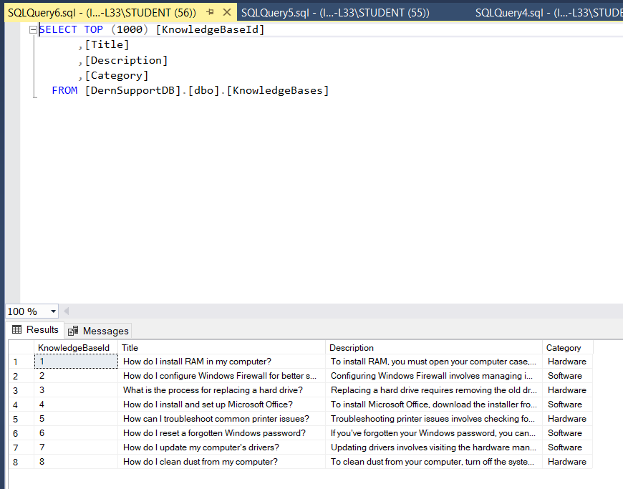

KnowledgeBases Table 1

Projects Table:  
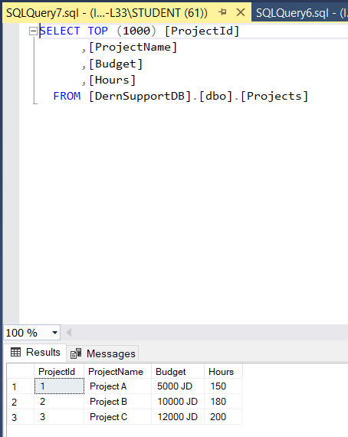

Projects Table 1

Technician Table:  
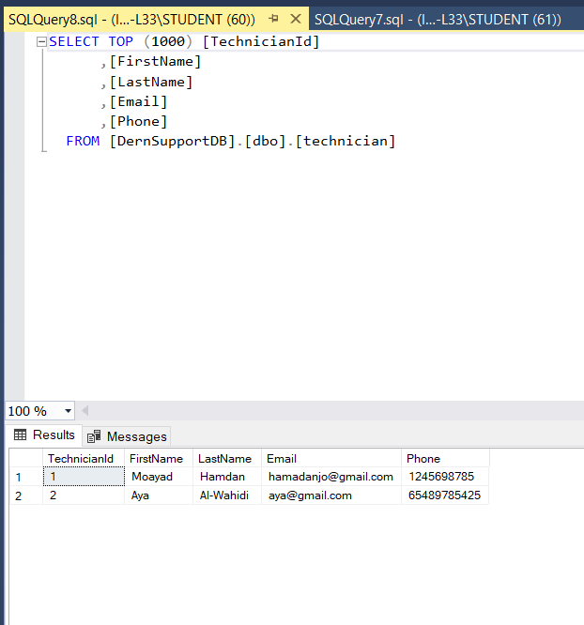

Technician Table 1

TechnicianProjectsDBset Table:  
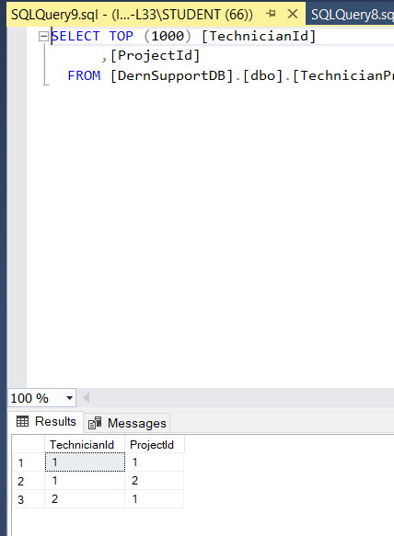

TechnicianProjectsDBset Table 1

TechnicianTasksDb Table:  
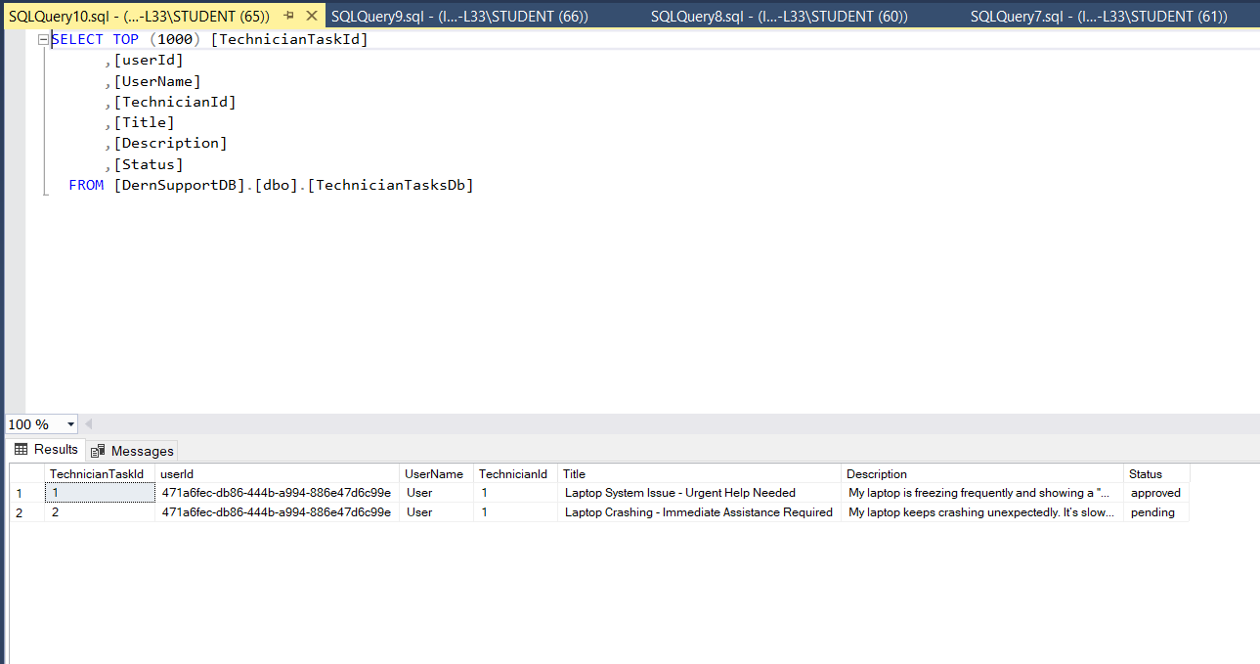

TechnicianTasksDb Table 1

## 3.2 Effectiveness

* **Problem Resolution:** The system effectively addresses key challenges, including support request management and inventory tracking.
* **User Feedback:** Generally positive, with identified areas for improvement addressed in the refinement phase.

## 3.3 Requirement Fulfillment

* **Customer Account Management:** Both individual and business accounts are functioning as required.
* **Support Request Handling:** Submissions, tracking, and history are managed effectively.
* **Inventory Management:** Real-time tracking and alerts are operational.
* **Job Scheduling:** Scheduling and prioritization are implemented successfully.

## 3.4 Future Development Suggestions

* **Automation:** Explore options for automated inventory reordering based on usage patterns.
* **Advanced Analytics:** Integrate predictive analytics for improved forecasting of potential issues.
* **Mobile Support:** Complete development of the mobile-friendly interface for broader accessibility.